Screenshots for Dasboard

1. AWS login screen with username

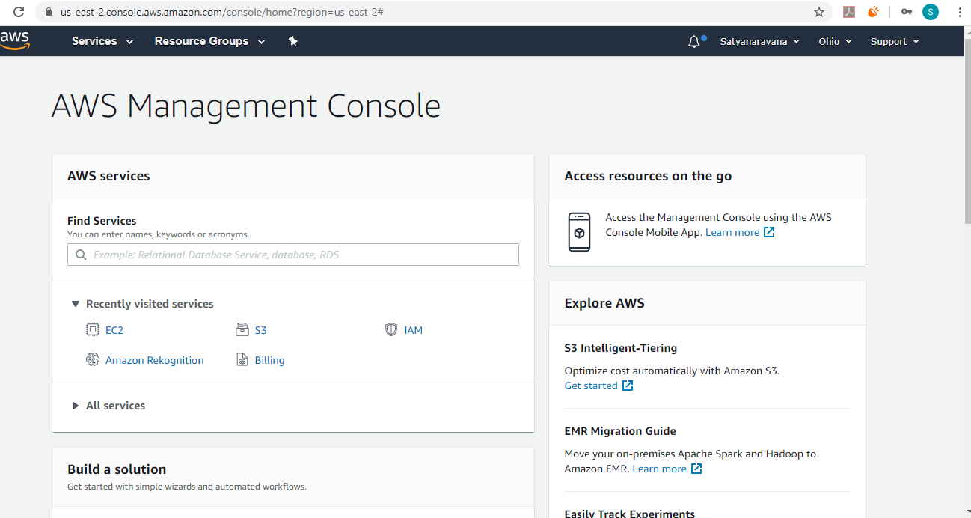

2. EC2 Dashboard

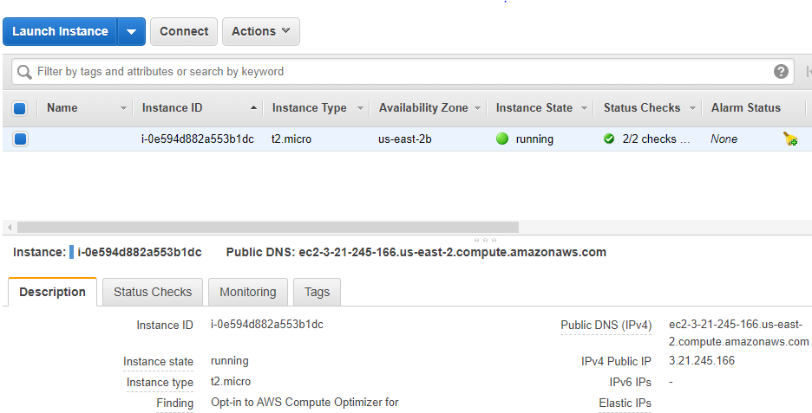

3. S3 Dashboard

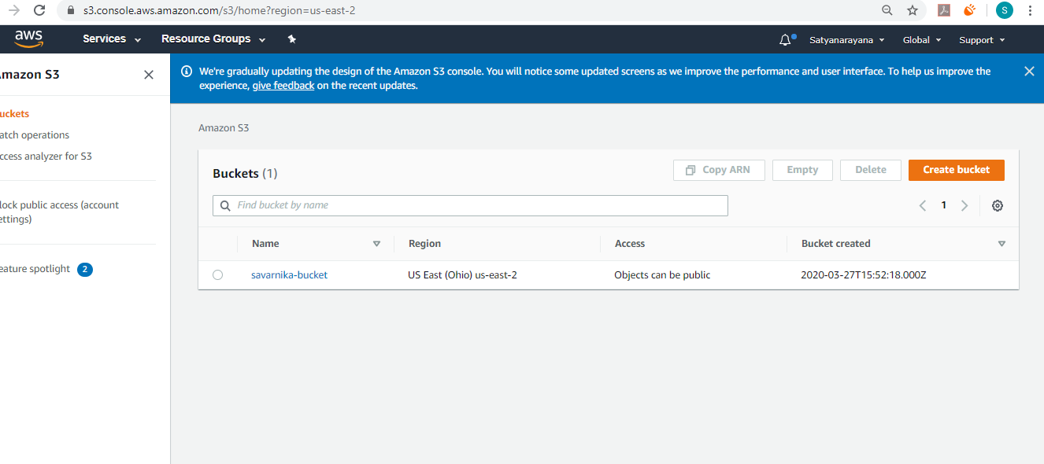

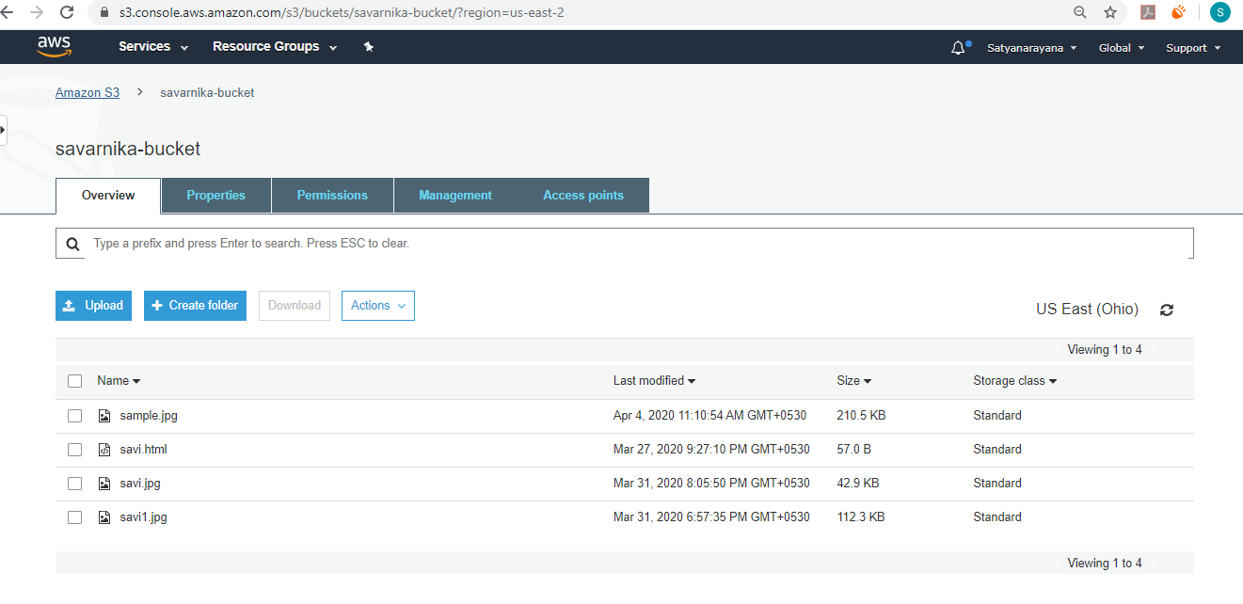

4. Rekognition Dashboard

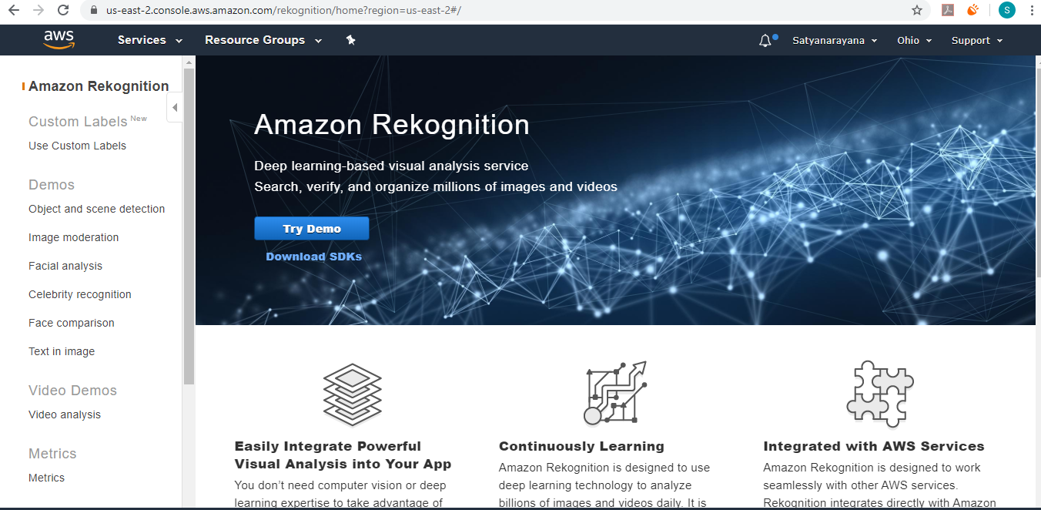

>> Screenshots for EC2

1. Choosing an AMI

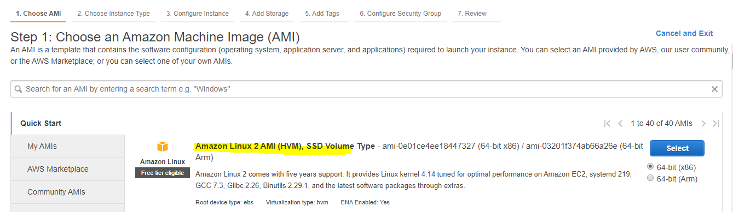

2. Choosing an Instance type

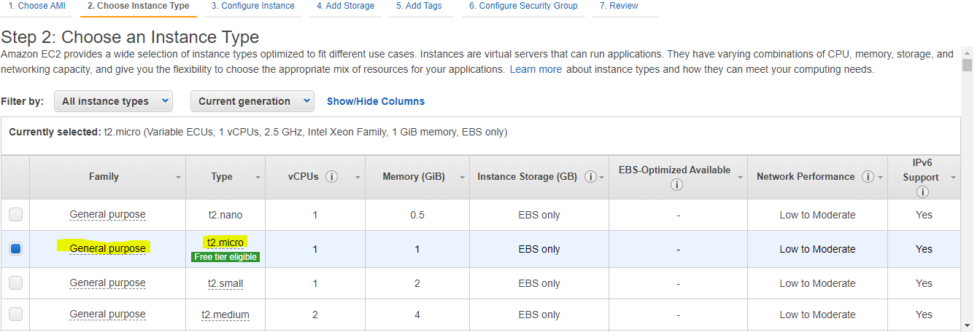

3. Adding Storage

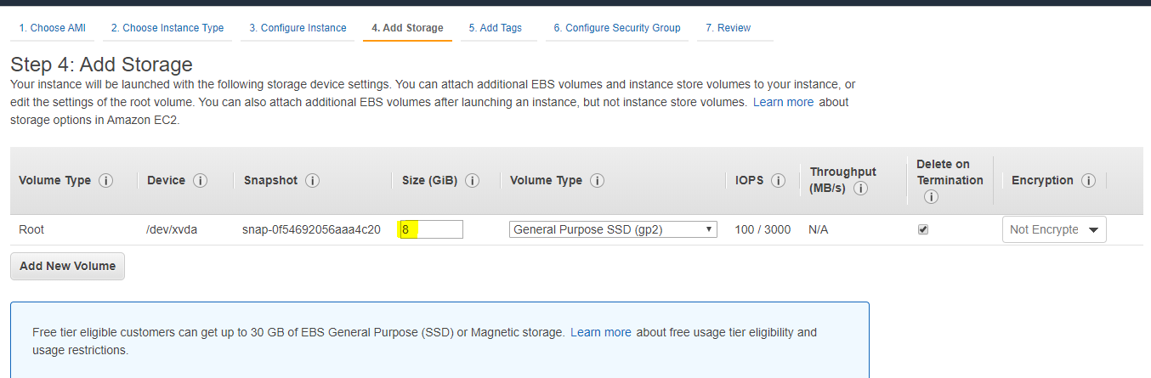

4. Configure Security group

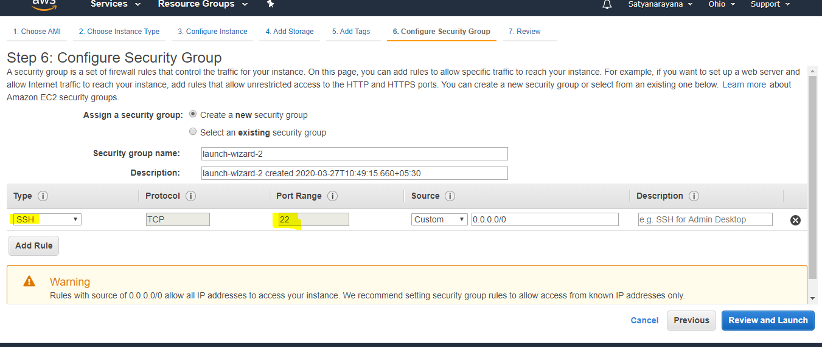

5. Key pair download

I did not take the screenshot while downloading I can provide the image while using the ppk file

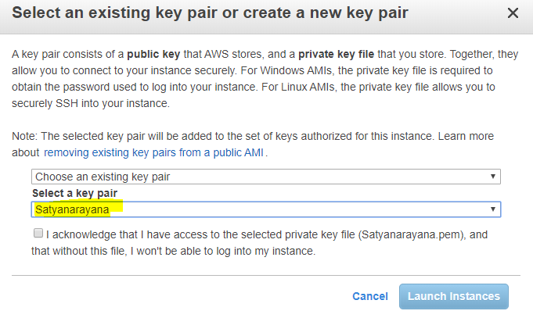

6. PuTTYgen conversion from pem to ppk

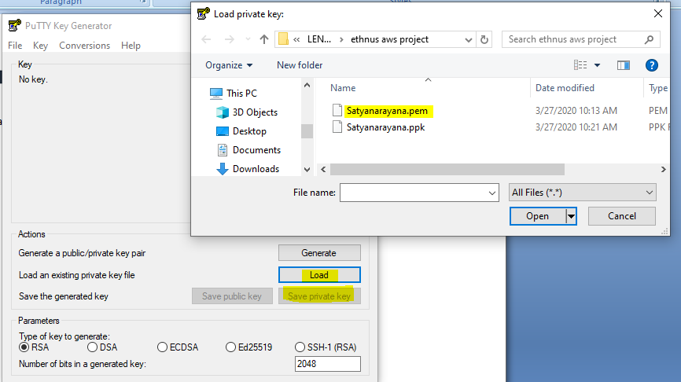

7. Logged in EC2 black screen

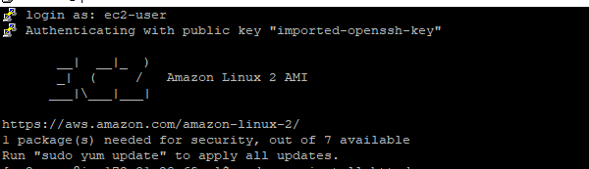

>>Screenshots for S3

1. Creating a bucket

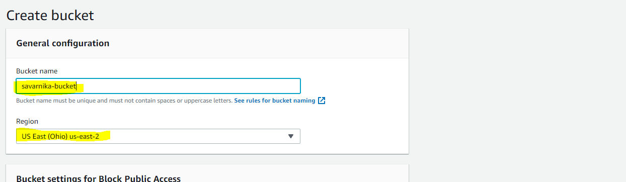

2. Uploading an Object

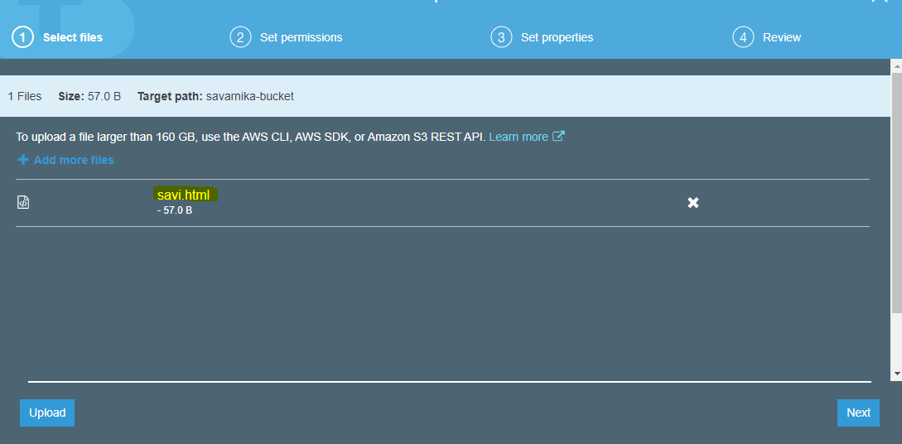

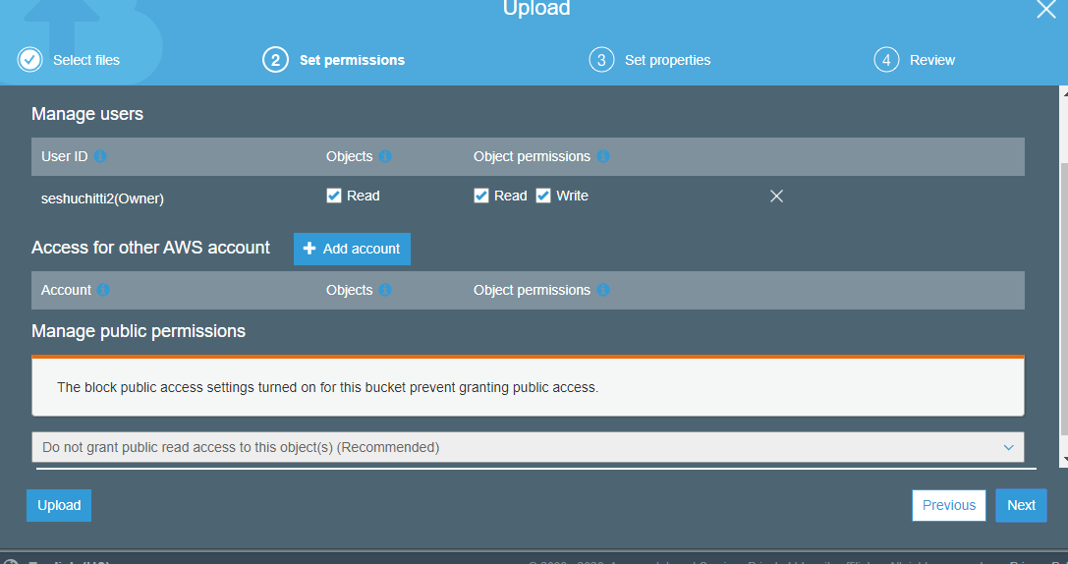

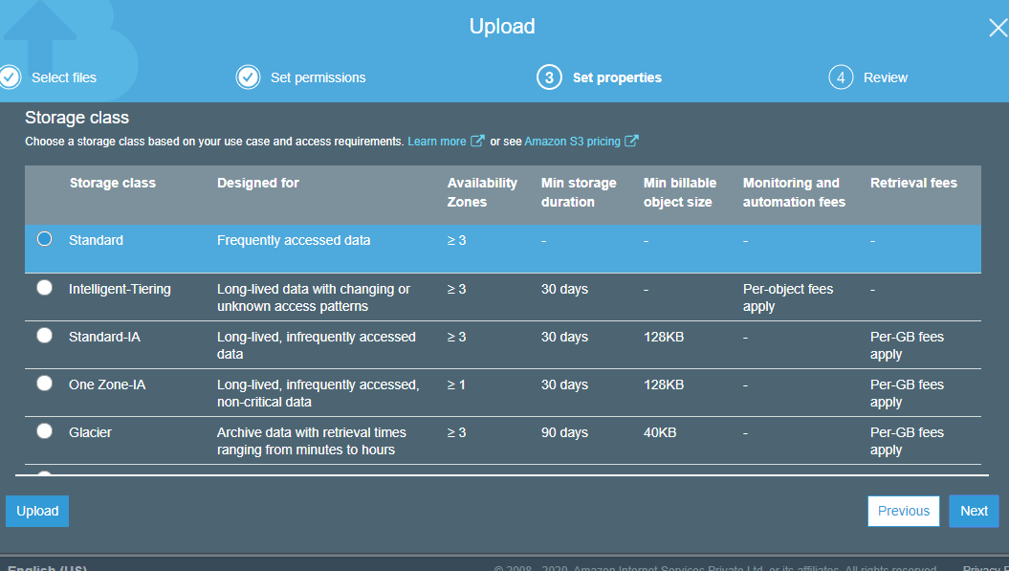

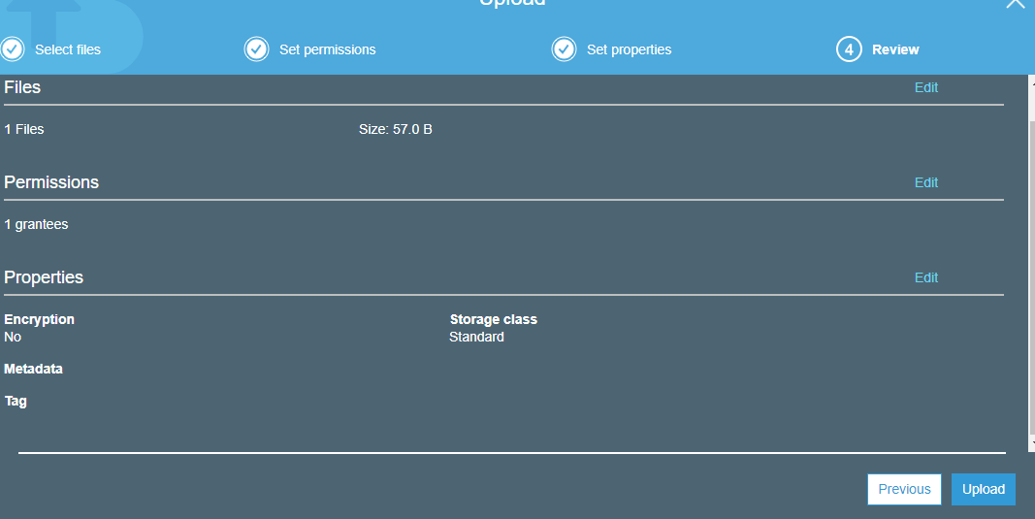

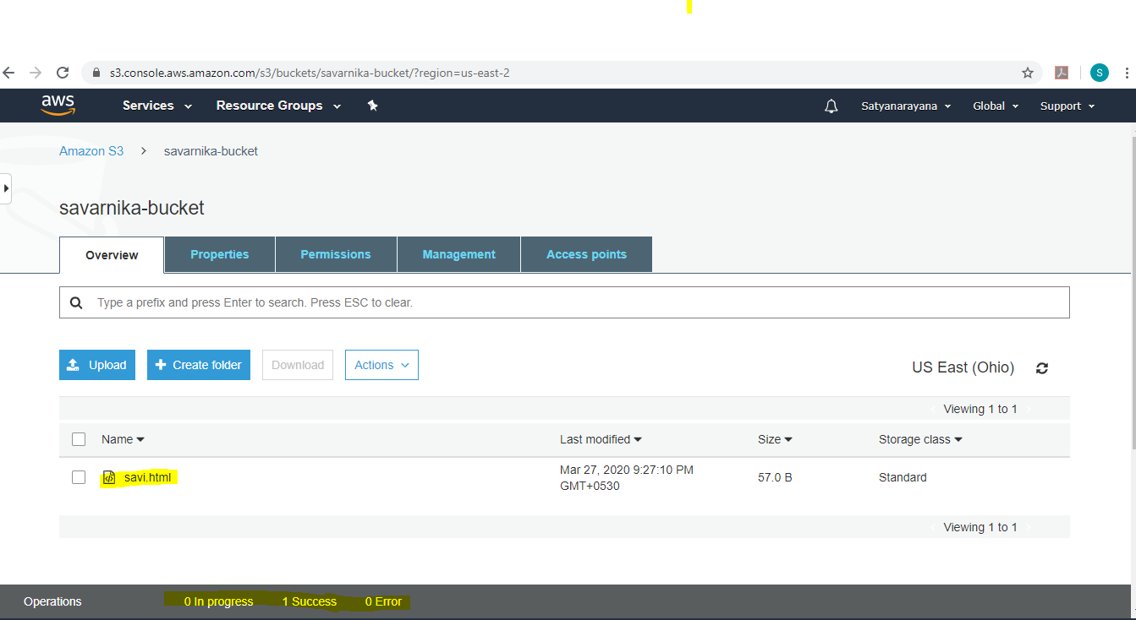

3. Enabling Static Website

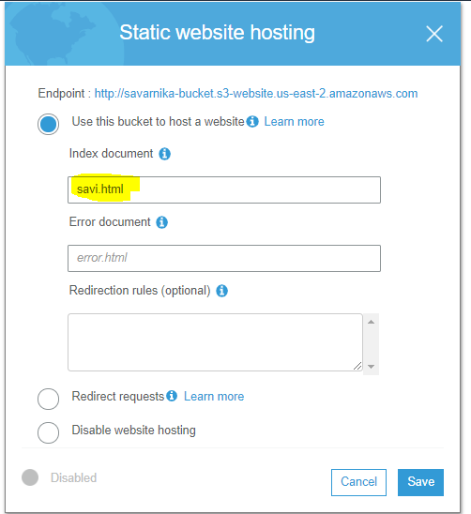

4. Making object public

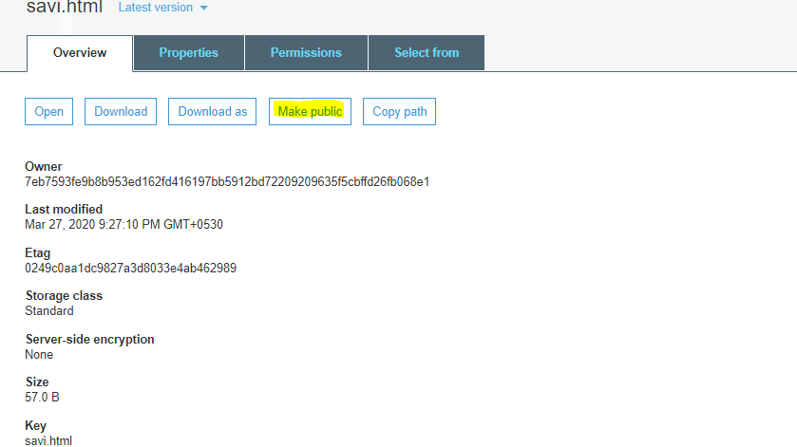

5. Checking the S3 link on the browser

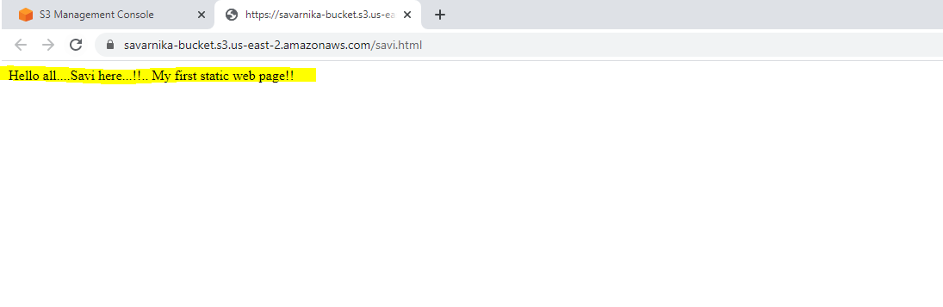

>>Screenshots for Rekognition

1. Face detect

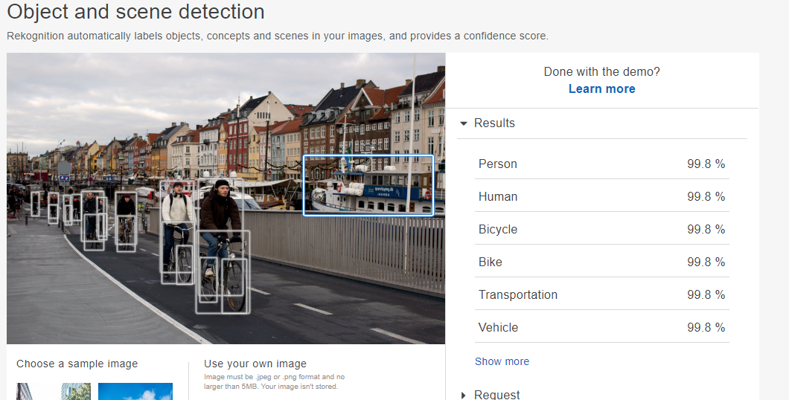

2. Face Compare

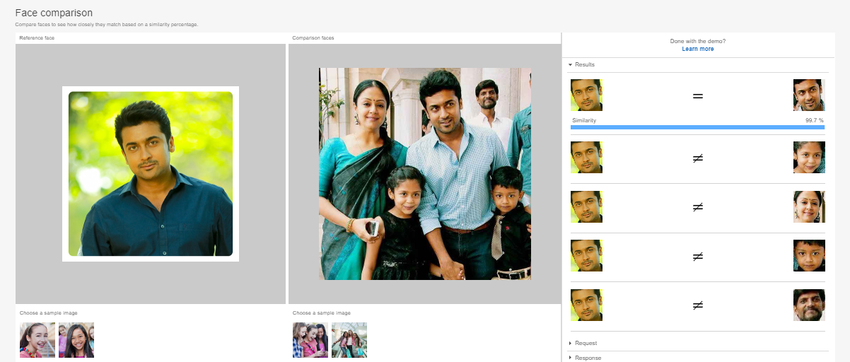

3. Celebrity Recognition

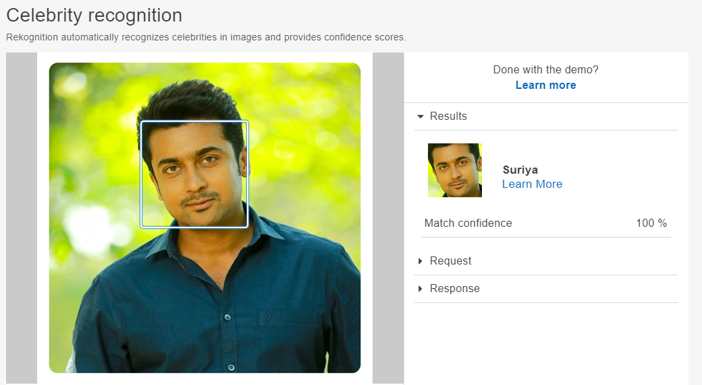

4. Text in image

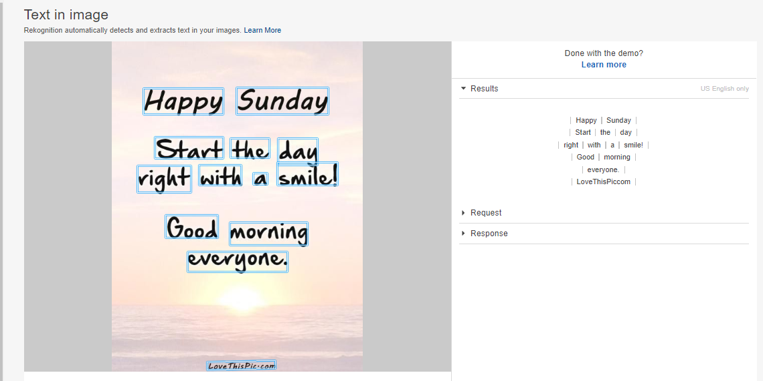

>>Screenshots for EC2 and S3

1. Installing aws-sdk

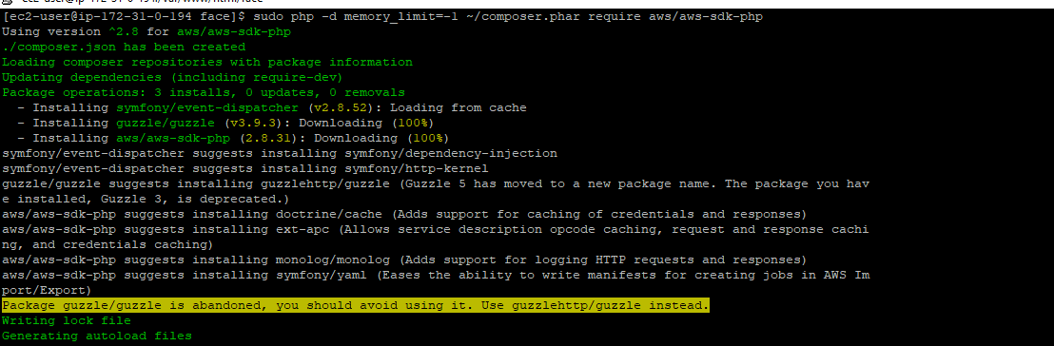

2. Installing php

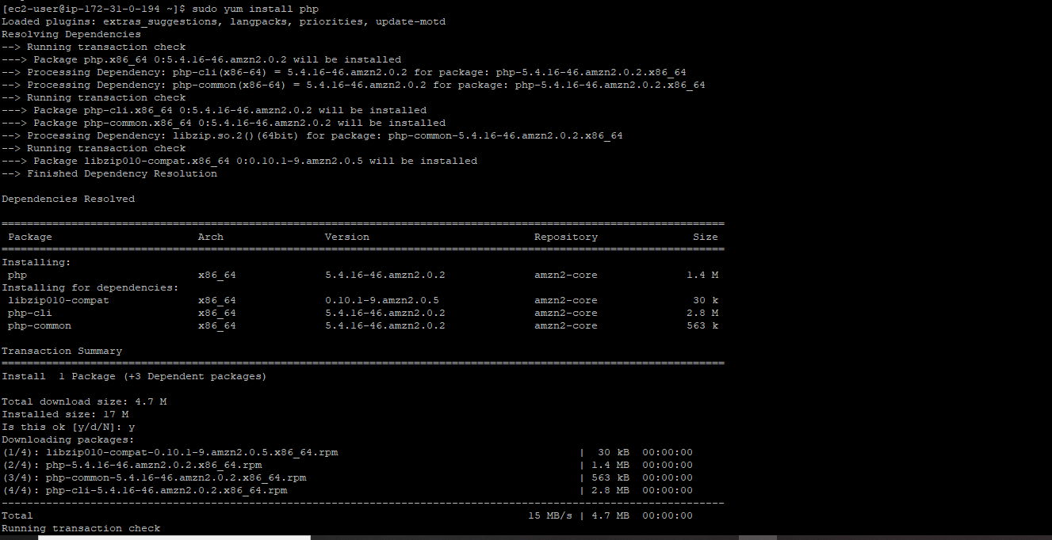

3. index.php file code

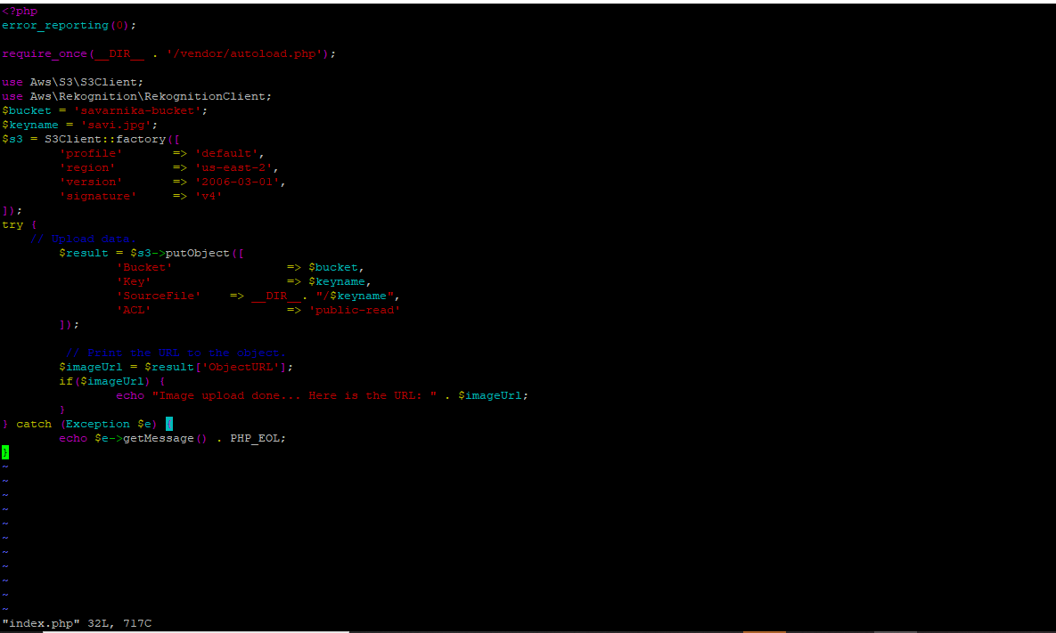

4. Upload success screenshot



>>Screenshots for EC2 and Rekognition

1.Faces detect success Screenshot

